**CST8256 Web Programming Language I**

Lab 5

# Objective

1. Use LINQ to Entity to create, read, update and delete (**CRUD**) data items to database via Microsoft Entity Framework.

# Due Date

See Brightspace posting for the due date. To earn 5 points, you are required:

1. Complete the lab as required.
2. Zip your **website** into a zip file and submit the zip file to Canvas
3. Demonstrate your lab work.

# Requirements

This lab is the continuation of lab 4 to create a student academic record application. The application consists of the following pages:

1. Default Page

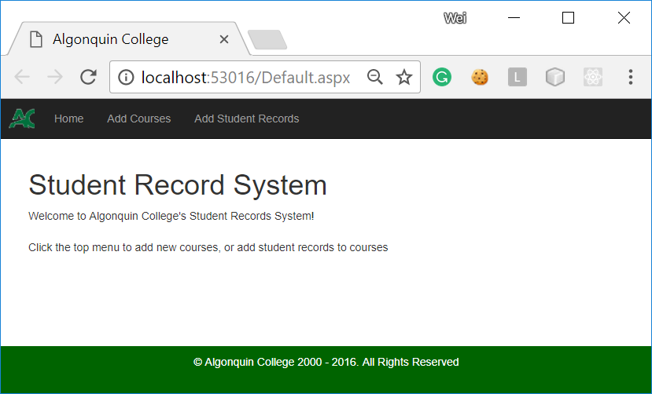

Although this page looks that same as the home page of lab 3, you should implement this page by inheriting from the **BasePage** class defined in BasePage.cs file:

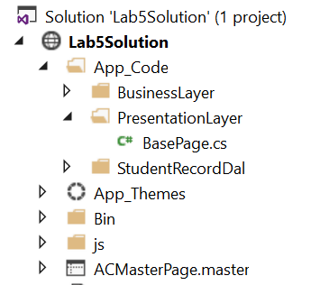

This is a common practice for an application to define a common base to implement functionality common to all pages. All pages of the application inherit from this base will automatically acquire these common functionality. Each page can add additional functionality as needed.

* Study the BasePage.cs and find out what functionality it implements.
* Since this is the home page, the Home top menu link should be disabled.

1. Add Course page

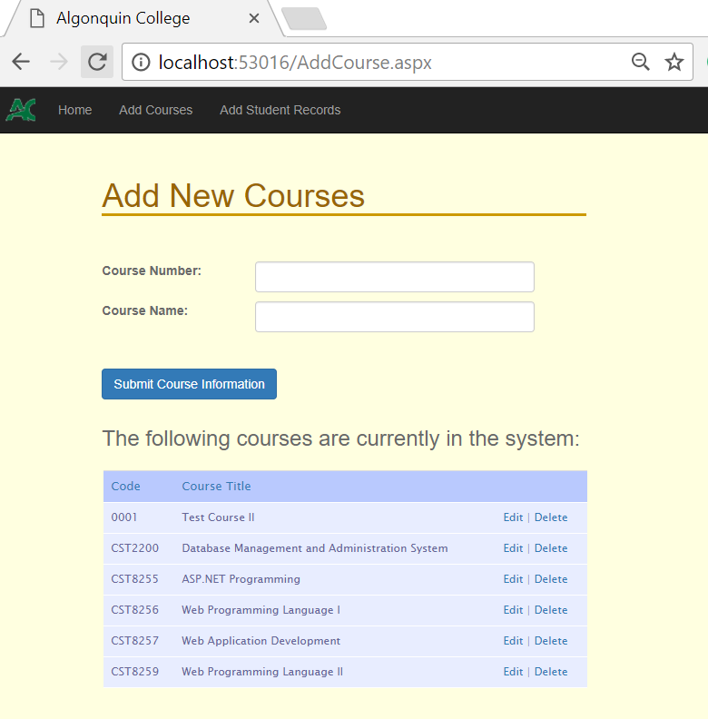

On this page, the user can add a new course into **StudentRecord** database you created in lab 4. It also displays the courses currently in the database. Once again, you should implement this page by inheriting from the **BasePage** class

* **Add Course** top-menu item should be disabled.
* All fields are required.
* If the entered course number already exists in the database, the user should get an error message.



* The user can choose to delete a course by clicking **Delete** link. Application should warn the user and delete the selected course and all the academic records associated with this course after get the confirmation from the user:

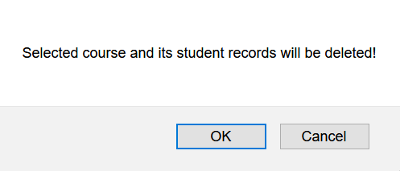

The prompting dialog box may look different from different type of browsers.

* The user can choose to edit an existing course by clicking **Edit** link. The application will population the Course Number and Course Name text fields with those of the selected course. The Course Number text field should be read-only. The user can only change the name of the course.

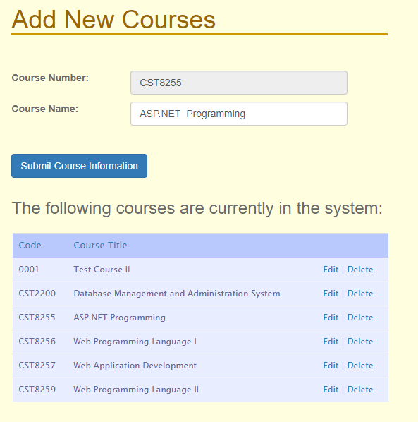

The user save the updated course Name by clicking **Submit Course Information** button.

1. Add Student Record page

On this page, the user can add a new student record into **StudentRecord** database you created in lab 4. It also displays the student records currently in the database of the course selected from the dropdown list. Once again, you should implement this page by inheriting from the **BasePage** class.

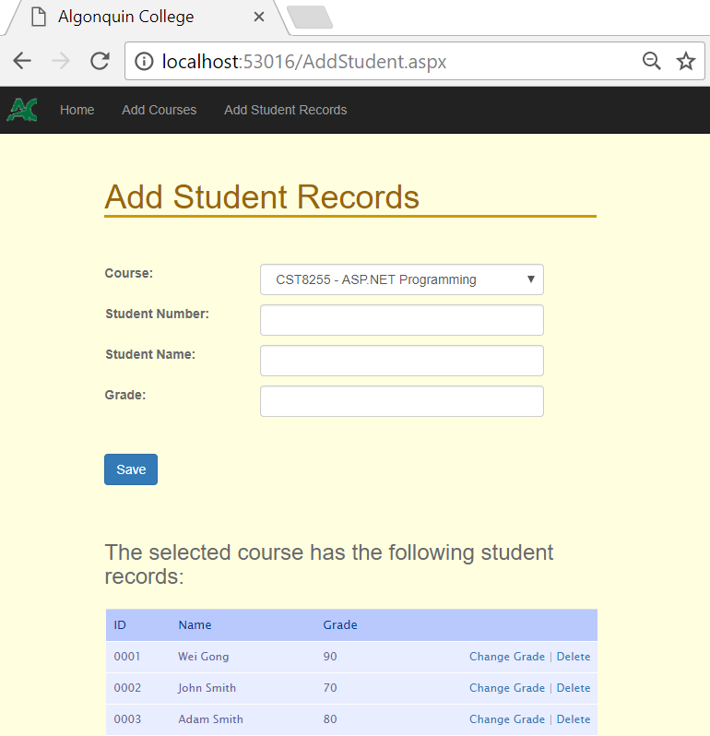

* **Add Student Record** top-menu link should be disabled on this page
* All fields are required.
* After the use entered all fields and click save button:
  + If the entered student number does not exist in the **StudentRecord** database yet, the application created and save into the database a new student and a new academic record for the student and the selected course.
  + If the entered student number already exist in the database, but there is no academic record for the student and the selected course, the application creates and save to the database a new academic record for the student and the selected course.
  + If the entered student number already exist in the database, and there is already an academic record for the student and the selected course, the application displays an error message to inform the user as such.

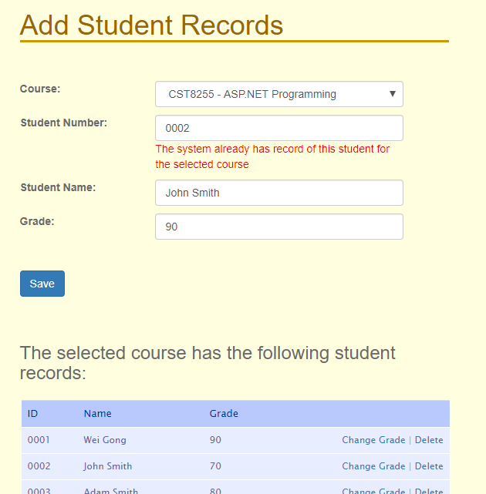

* The user can choose to delete an academic record by clicking **Delete** link. Application should warn the user and delete the selected academic record after getting the confirmation from the user. Only the academic record will be deleted from the user, the student data will not be deleted from the database.

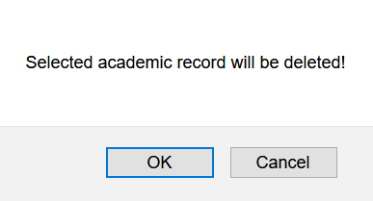

* The user can choose to change the grade of an existing academic record by clicking **Change** **Grade** link. The application will population the Student Number and Student Name text fields with those of the selected student. The course dropdown list should become disabled. Student Number and Student Name text fields should become read-only. The user can only change the grade of the selected academic record.

